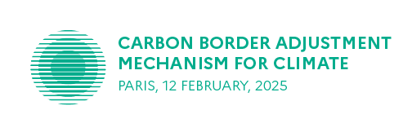France is honoured to convene representatives of the European Commission, EU Member States, third countries, international organizations, academics and experts, and civil society stakeholders for a high-level international virtual conference on carbon leakage and the carbon border adjustment mechanism, which will be held on February 12th, 2025 in the afternoon in Paris.

SOCIAL MEDIA KIT #CBAMforClimate

As a participant/speaker, you can help us maximize the impact of the event and the global reach of our priorities. Please use this document to contribute to the outreach of the event with your social media accounts.

You will find in this document:

1. Online resources
2. Examples of possible social media posts
3. Event logo

#CBAMforClimate #CBAM #MACF

@Eric_R_Lombard @Economie_Gouv @DGTresor

@French_Gov

1. Online resources

> Presentation of the event, agenda: <https://www.economie.gouv.fr/actualites/les-enjeux-economiques-de-la-transition-vers-la-neutralite-carbone>

> Read more about the context of the event: <https://www.tresor.economie.gouv.fr/Articles/2025/01/24/carbon-border-adjustments-mechanism-for-climate-addressing-carbon-leakage-to-strengthen-global-climate-action>

On February 12, the event will be broadcast online live on the French Treasury website: <https://www.tresor.economie.gouv.fr/Evenements/2025/02/12/un-mecanisme-d-ajustement-carbone-aux-frontieres-en-faveur-du-climat>

1. Social media post examples suitable for LinkedIn, Facebook and X

**Post #1: participant**

* Before the event:

Carbon Border Adjustments Mechanism for Climate: Addressing carbon leakage to strengthen global climate action.

Join the #CBAMforClimate high level conference on February 12. Register ➡ http://cbamforclimate.dg-tresor.fr/ #CBAM

* On the day of the event:

Carbon Border Adjustments for Climate: Addressing carbon leakage to strengthen global climate action.

Watch the #CBAMforClimate high level conference live online ➡ <https://www.economie.gouv.fr/actualites/les-enjeux-economiques-de-la-transition-vers-la-neutralite-carbone> #CBAM

Post #2: speaker

*Modify the highlighted text according to your name/name of your entity.*

* Before the event

Join me on February 12 to discuss Carbon Border Adjustments for Climate #CBAMforClimate, on panel Number of the session/Name of the session. Agenda and registration ➡ <http://cbamforclimate.dg-tresor.fr/> #CBAM

* On the day of the event

#CBAMforClimate Carbon Border Adjustments for Climate: join me today at X:00 PM for the online high level international conference. Watch live ➡ <https://www.economie.gouv.fr/actualites/les-enjeux-economiques-de-la-transition-vers-la-neutralite-carbone> #CBAM

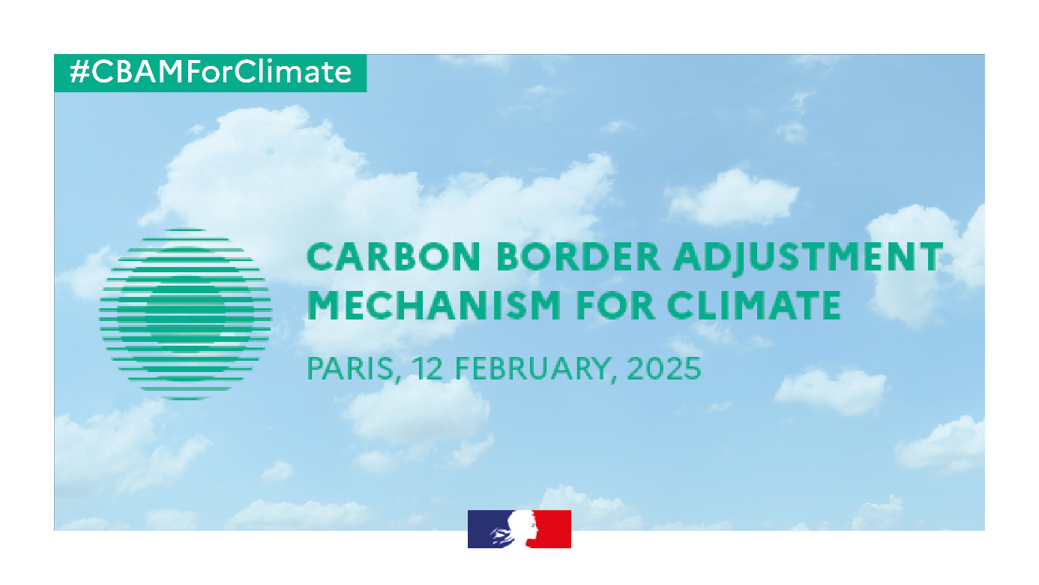*You can use the social media vignette below to illustrate your post:*

**Introduction**

* @Eric_R_Lombard @Economie_Gouv

**Session 1 : Lessons learnt from the first year of the implementation of the CBAM**

* Andrei Marcu @ERCST_org
* @gerass_thomas @EU_Taxud @EU_Commission
* Luisa Santos @BusinessEurope
* @RBatier @AEGISeurope
* Mark Bressers @NEaOnline

**Session 2 : What evolutions of the CBAM are to be expected in the coming years ?**

* @gerass_thomas @EU_Taxud @EU_Commission
* Olivier Brault @GroupeSEB
* @adrienassous @sandbag_eu
* Frauke Thies @AgoraEW
* @mmehling @MIT

**Session 3 : Cooperation with third countries on carbon pricing**

* @FLapecorella @OECD
* Sébastien Paquot @EUClimateAction
* Helen Dickinson @hmtreasury
* @ProfHasar @TC_iklim
* @AaronCosbey @IISD_news

**Conclusion**

* @Eric_R_Lombard @Economie_Gouv

1. Event logo

